Name: Kushaal Shyam Potta | Reg. No: 3122235001071
Exp. No: 5 | Date: 07-08-2026

Implementation of Syntax Checker using Lex and Yacc Tools
Aim:
To build a syntax checker with Lex and Yacc that recognizes declaration, assignment, conditional and looping statements, using a suitable grammar for each. It works on C++ source: apart from the C-like statements it accepts the bool type, cout << and cin >> statements, return, #include and using namespace lines, and an int main() wrapper.
Tools Used:
- Flex, the lexical analyzer generator
- Bison, the parser generator (Yacc)
- GCC
Code:
syntax.l
%{
#include "y.tab.h"
%}

%option yylineno noyywrap nounput noinput

DIGIT [0-9]
LETTER [a-zA-Z_]

%%

"//".* ;
"/*"([^*]|\*+[^*/])*\*+"/" ;

^[ \t]*"#"[^\n]* ;
"using"[ \t]+"namespace"[ \t]+{LETTER}({LETTER}|{DIGIT})*[ \t]*";" ;

"int"|"float"|"char"|"double"|"bool" { return TYPE; }
"return" { return RETURN; }
"std::"?"cout" { return COUT; }
"std::"?"cin" { return CIN; }
"std::"?"endl" { return ENDL; }
"true"|"false" { return NUM; }
"if" { return IF; }
"else" { return ELSE; }
"while" { return WHILE; }
"do" { return DO; }
"for" { return FOR; }

{LETTER}({LETTER}|{DIGIT})* { return ID; }
{DIGIT}+(\.{DIGIT}+)? { return NUM; }
\"([^"\\\n]|\\.)*\" { return STR; }
\'([^'\\]|\\.)\' { return NUM; }

"++" { return INC; }
"--" { return DEC; }
"<<" { return SHL; }
">>" { return SHR; }
"&&" { return AND; }
"||" { return OR; }
"=="|"!=" { return EQOP; }
"<="|">="|"<"|">" { return RELOP; }
"!" { return NOT; }
"=" { return '='; }
[+\-*/%] { return yytext[0]; }
[(){};,] { return yytext[0]; }

[ \t\r\n] ;
. { return yytext[0]; }

%%

syntax.y
%{
#include <stdio.h>

int yylex(void);
void yyerror(const char *s);

extern int yylineno;
extern char *yytext;
%}

%token TYPE IF ELSE WHILE DO FOR ID NUM STR
%token RETURN COUT CIN ENDL SHL SHR
%token INC DEC AND OR EQOP RELOP NOT

%left OR
%left AND
%left EQOP
%left RELOP
%left '+' '-'
%left '*' '/' '%'
%right NOT UMINUS

%nonassoc LOWER_THAN_ELSE
%nonassoc ELSE

%%

program : stmt_list
| function
;

/* int main() { ... } (optionally int main(void) ) */
function : TYPE ID '(' ')' block
| TYPE ID '(' TYPE ')' block
;

stmt_list : stmt_list stmt
| stmt
;

stmt : decl_stmt
| assign_stmt
| if_stmt
| while_stmt
| do_stmt
| for_stmt
| io_stmt
| return_stmt
| block
| ';'
;

/* Output / input statements: cout << a << "text" << endl; cin >> a; */
io_stmt : COUT out_list ';'
| CIN in_list ';'
;

out_list : SHL out_item
| out_list SHL out_item
;

out_item : STR
| ENDL
| expr
;

in_list : SHR ID
| in_list SHR ID
;

return_stmt : RETURN expr ';'
| RETURN ';'
;

block : '{' stmt_list '}'
| '{' '}'
;

/* Declaration statement: int i, a = 5; */
decl_stmt : TYPE decl_list ';'
;

decl_list : decl_list ',' declarator
| declarator
;

declarator : ID
| ID '=' expr
;

/* Assignment statement: i = i + 1; i++; */
assign_stmt : simple_stmt ';'
;

simple_stmt : ID '=' expr
| ID INC
| ID DEC
;

/* Conditional statements: if, if-else */
if_stmt : IF '(' expr ')' stmt %prec LOWER_THAN_ELSE
| IF '(' expr ')' stmt ELSE stmt
;

/* Looping statements: while, do-while, for */
while_stmt : WHILE '(' expr ')' stmt
;

do_stmt : DO stmt WHILE '(' expr ')' ';'
;

for_stmt : FOR '(' simple_stmt ';' expr ';' simple_stmt ')' stmt
;

expr : expr OR expr
| expr AND expr
| expr EQOP expr
| expr RELOP expr
| expr '+' expr
| expr '-' expr
| expr '*' expr
| expr '/' expr
| expr '%' expr
| NOT expr
| '-' expr %prec UMINUS
| '(' expr ')'
| ID
| NUM
;

%%

void yyerror(const char *s) {
printf("Syntax Error at line %d near '%s'\n", yylineno, yytext);
}

int main(void) {
if (yyparse() == 0)
printf("Syntactically correct\n");
return 0;
}

Input (input.txt)
int i, a;
i = 0;
a=5;
while (i < 10)
{
if ( i<a)
i = i + 1;
else
i = i - 1;
}

Commands Used
lex syntax.l
yacc -d syntax.y
cc lex.yy.c y.tab.c -lfl -o syncheck
./syncheck < input.txt

Output:
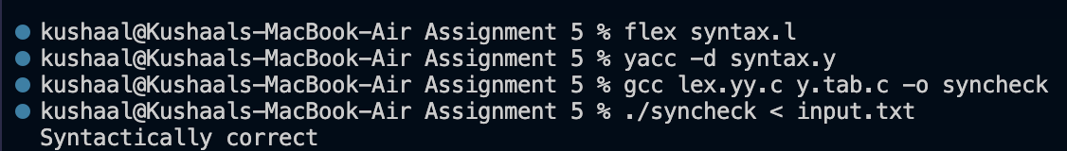
Result for the given input
The grammar has no conflicts: operator precedence and associativity are set with %left / %right and the dangling else is settled with %prec LOWER_THAN_ELSE, so yacc reports no shift/reduce conflicts.
Additional Test Cases:
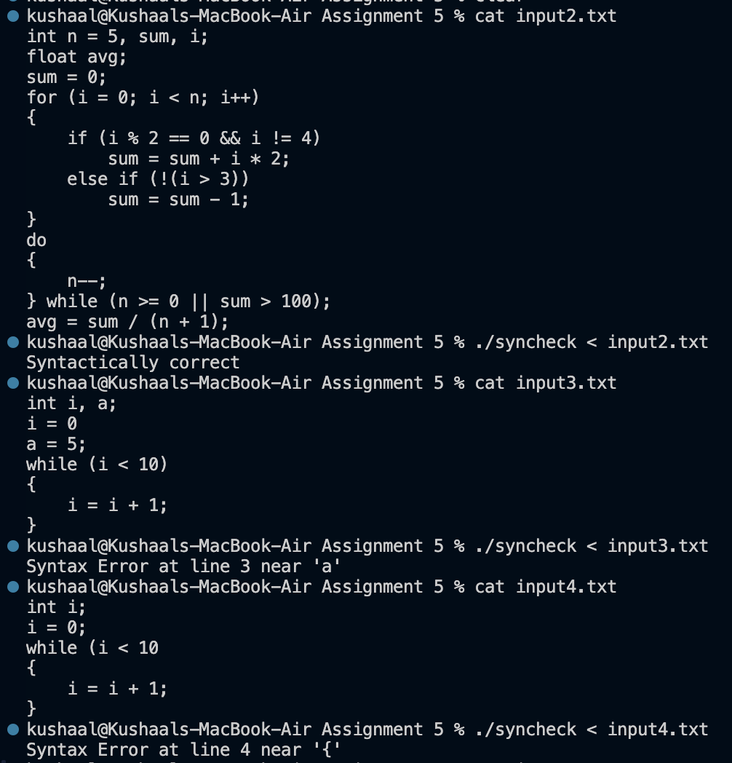
Further test cases: one valid program and two with syntax errors
input2.txt contains every kind of statement: declarations with initial values, for, if / else if, do-while, logical operators and increment / decrement. It is accepted as Syntactically correct.
input3.txt is missing the semicolon after i = 0, and input4.txt is missing the closing bracket of the while condition. The checker prints the line number and the token at which parsing can no longer continue.
C++ test cases (input5.txt and input6.txt):
input5.txt:
#include <iostream>
using namespace std;

int main()
{
int n = 5, sum = 0, i;
bool done = false;
cin >> n;
for (i = 0; i < n; i++)
{
if (i % 2 == 0 && i != 4)
sum = sum + i * 2;
else
sum = sum - 1;
}
cout << "Sum = " << sum << endl;
return 0;
}
Result: Syntactically correct

input6.txt (missing semicolon after endl):
#include <iostream>
using namespace std;

int main()
{
int a = 5;
cout << "a is " << a << endl
return 0;
}
Result: Syntax Error at line 8 near 'return'
Learning Outcomes:
- Learned to write a grammar for declaration, assignment, conditional (if-else) and looping (while, do-while, for) statements of a C / C++ like language.
- Understood how precedence declarations (%left, %right) and %prec eliminate shift/reduce conflicts, including the dangling else.
- Understood how Yacc generates a parser from BNF-style productions and reports syntax errors through yyerror, with yylineno giving the line number.
- Gained experience combining Lex tokens with a Yacc grammar to validate the structure of a small program.

